Graded Project - Week 1

Assessment:

**Problem statement**

Create an ARM template, which deploys a VM and the associated networking infrastructure

With the following parameters

1) OS: Windows 2019 datacenter

2) VM size : DS1_v2

3) Open ports: 3389

4) Storage option: Standard SSD

Other required values can be set as per your discretion

Submission of this assessment shall be done in the form of a pdf document containing the labelled

Screenshots of the ARM template files and the deployment process.

Arm template creation/generation:

To resource group -> Create new VM->Fill the details and download the template

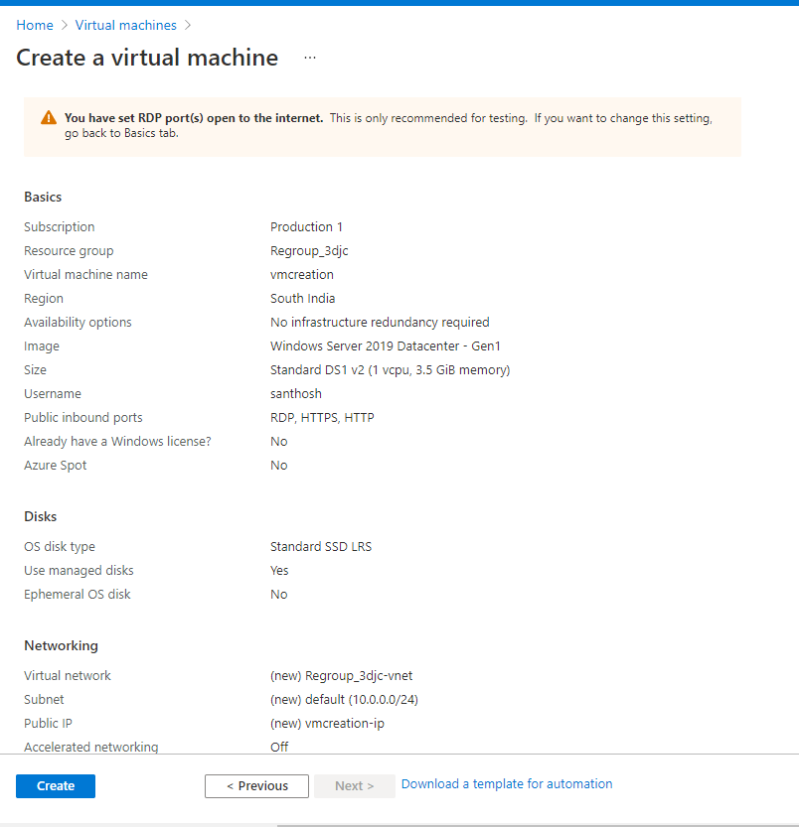  
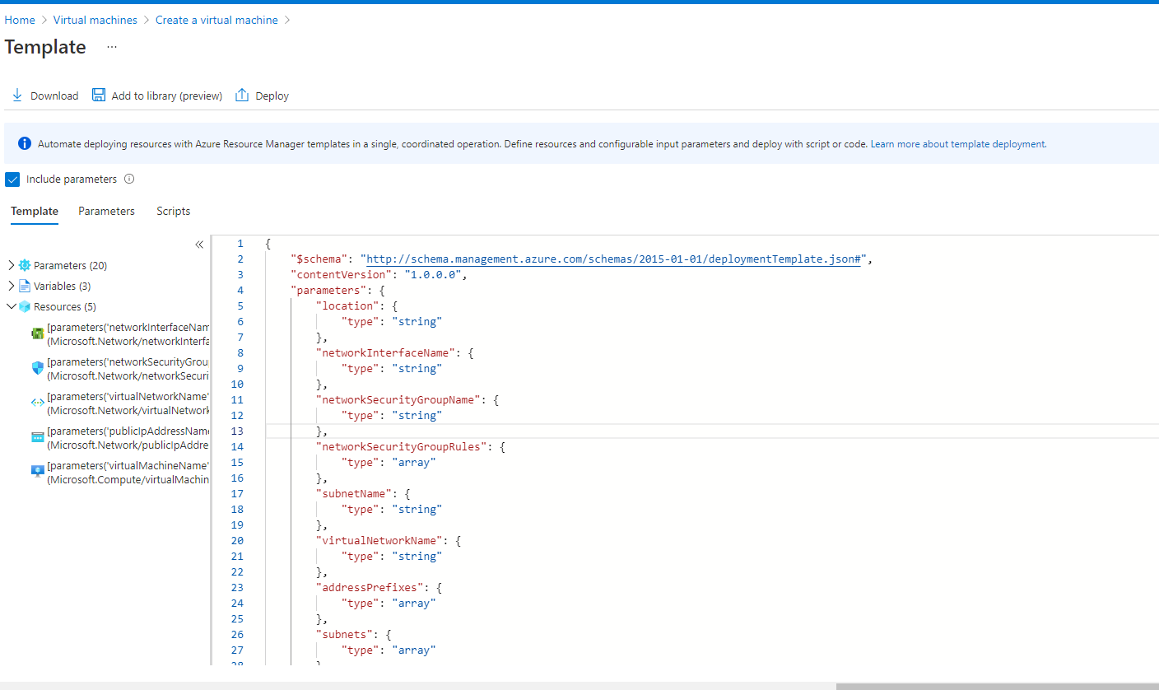

Parameters

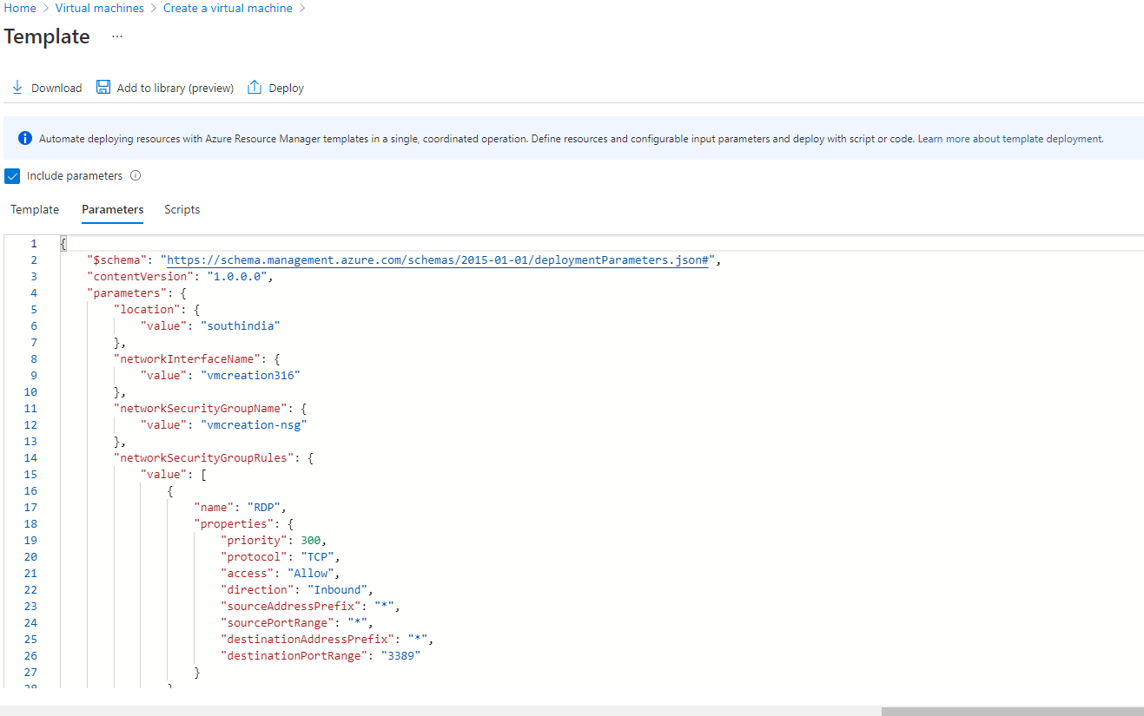

**Deployment of VM**

Deploy a custom template:

Search for deploy custom template to create resources using Arm templates  
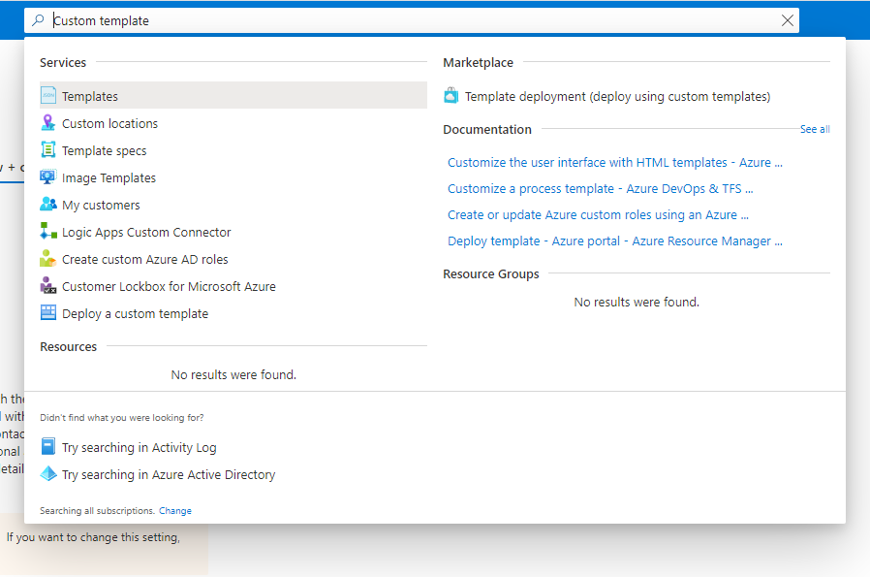

Click on Deploy a custom template:

Below screen will come up

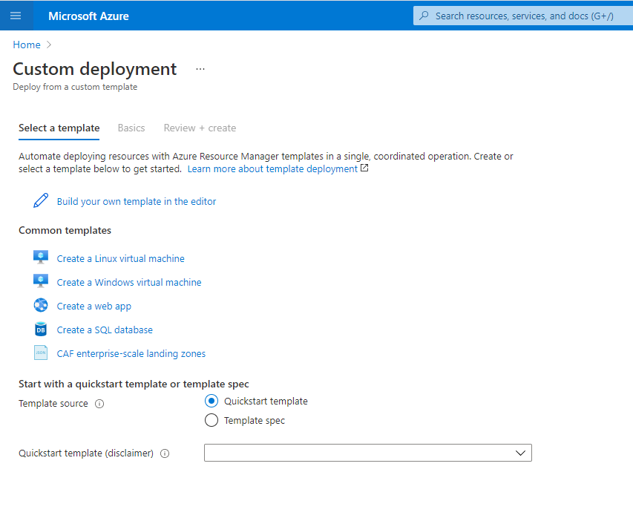

Steps:

* Build your own template
* Load file
* Upload template file / copy content Click on Save
* Click on Edit Parameters
* Upload parameter file / copy content Click on Save
* Select resource group and provide the password for vm
* Once validation is passed and Click on Create

Template:

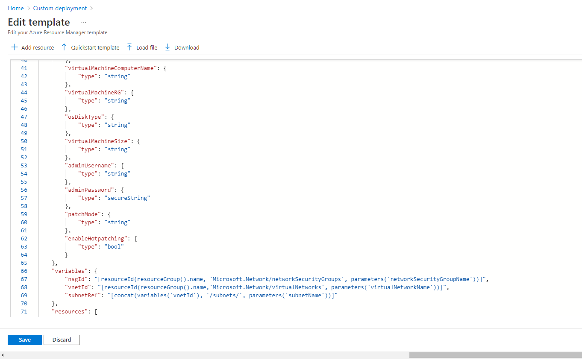

Edit parameter:

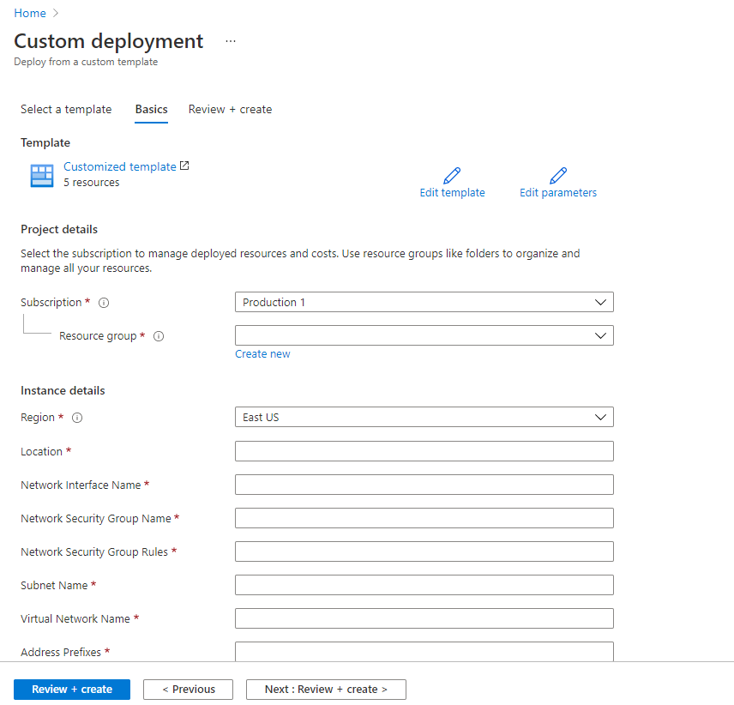

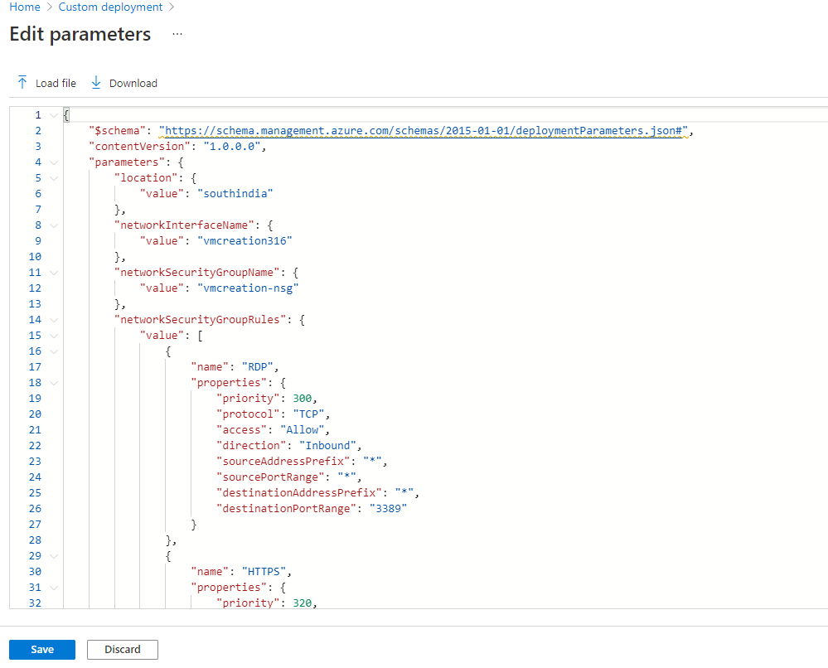

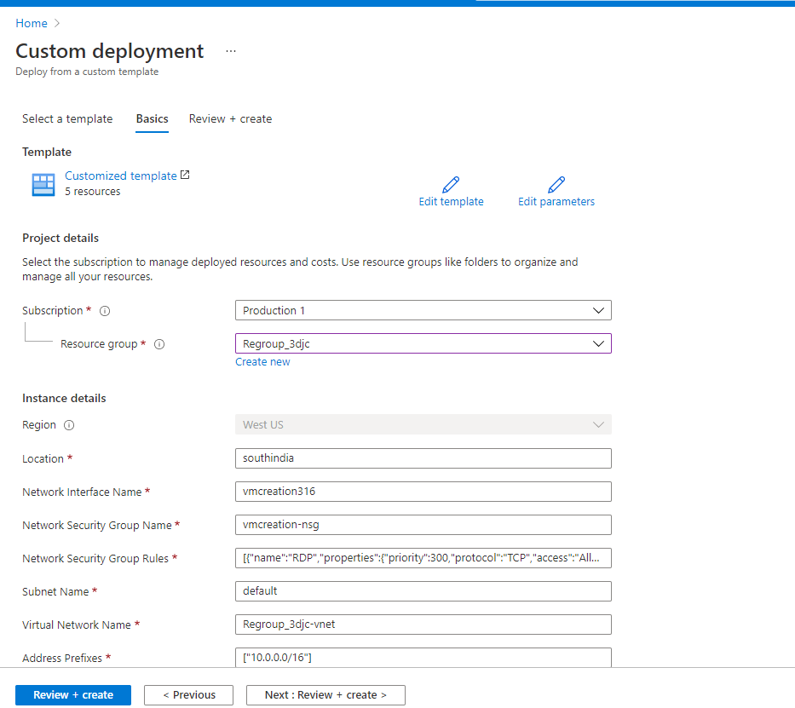

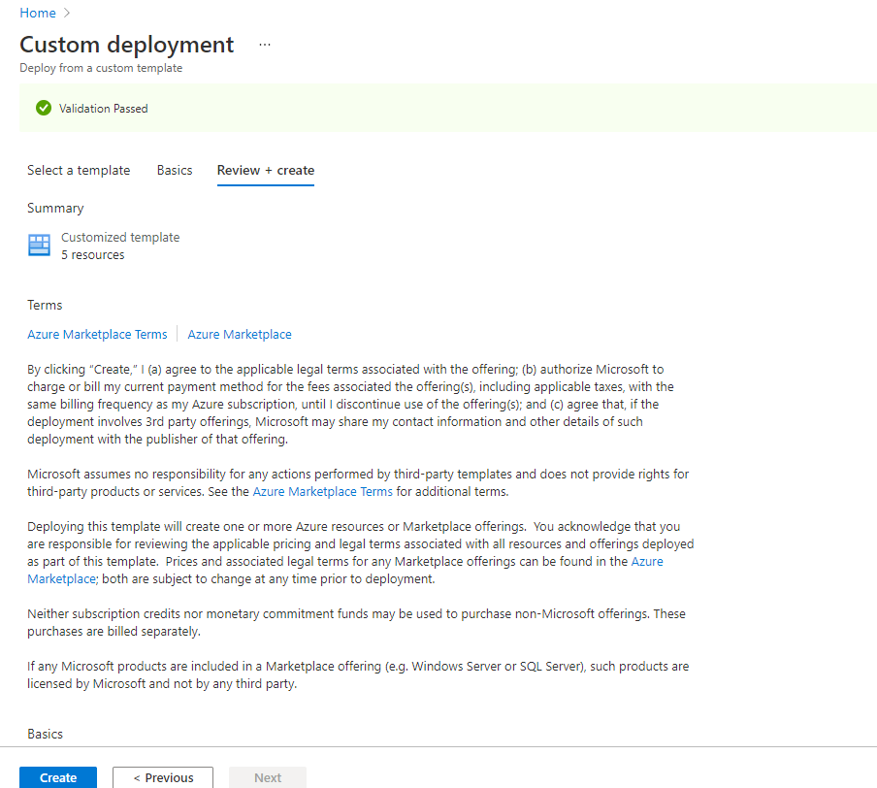

Deployment:

**Deployment of virtual network and Network Security Group**

In progress

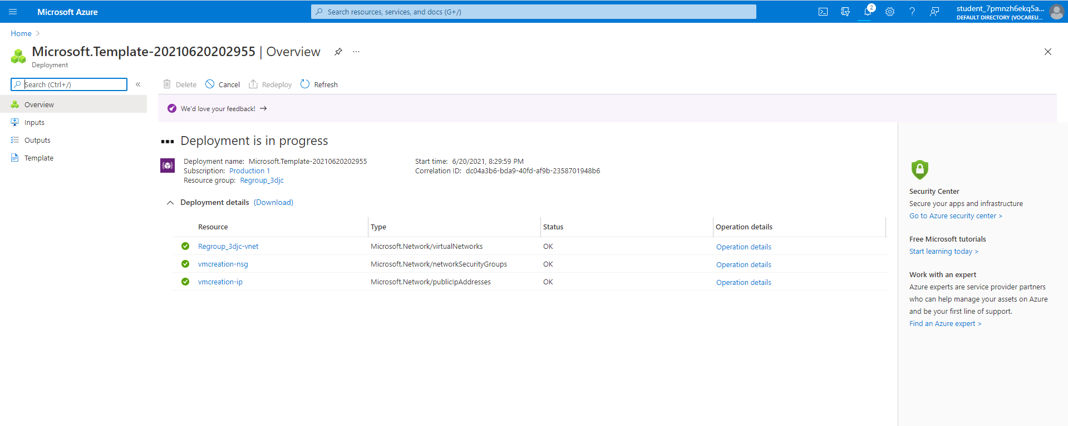

Completed:  
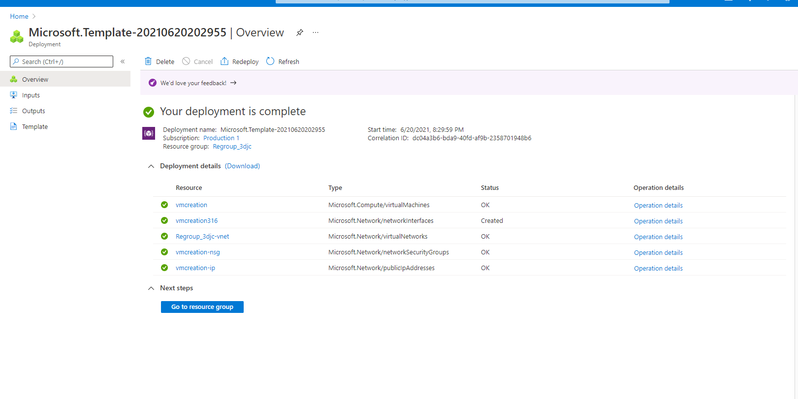

**To Connect VM:**

Download RDP file from Resource group->Virtual Machines

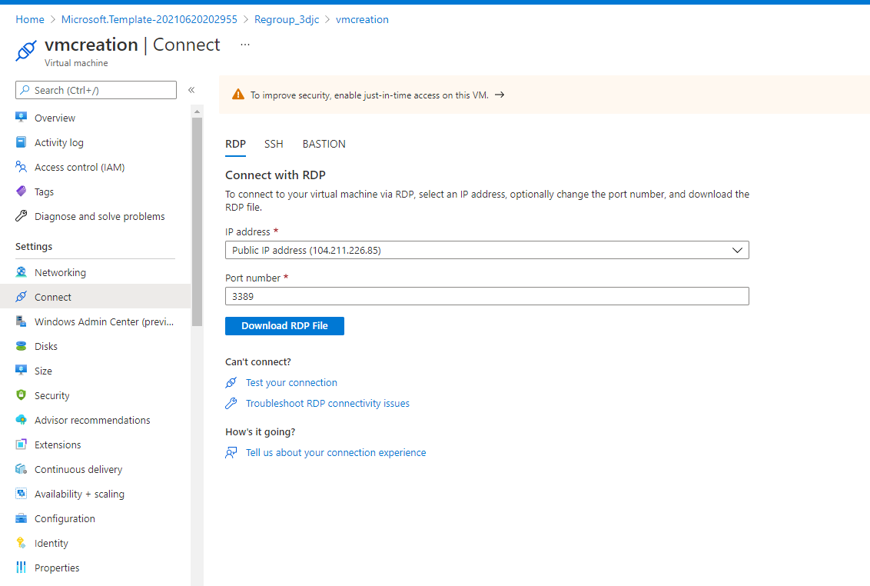

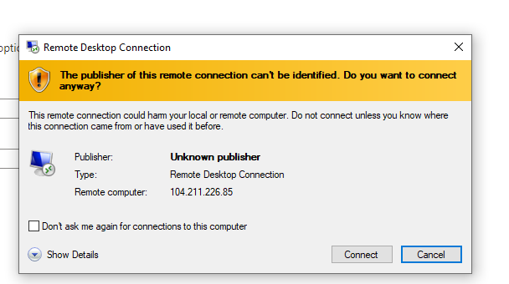

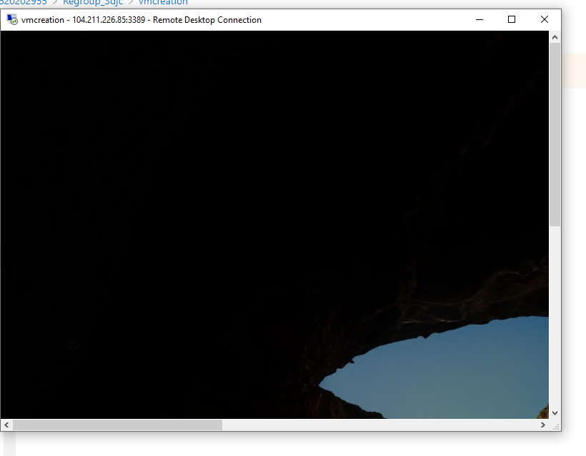

Template file: